**Handson 2: Web Api using .Net core with Swagger**

Superset id : 6363535

**Program.cs**

var builder = WebApplication.CreateBuilder(args);

builder.Services.AddControllers();

builder.Services.AddEndpointsApiExplorer();

builder.Services.AddSwaggerGen(c =>

{

c.SwaggerDoc("v1", new Microsoft.OpenApi.Models.OpenApiInfo

{

Title = "Swagger Demo",

Version = "v1",

Description = "TBD",

TermsOfService = new Uri("https://example.com/terms"),

Contact = new Microsoft.OpenApi.Models.OpenApiContact

{

Name = "John Doe",

Email = "john@xyzmail.com",

Url = new Uri("https://www.example.com")

},

License = new Microsoft.OpenApi.Models.OpenApiLicense

{

Name = "License Terms",

Url = new Uri("https://www.example.com")

}

});

});

var app = builder.Build();

// Configure the HTTP request pipeline.

app.UseHttpsRedirection();

app.UseAuthorization();

app.UseSwagger();

app.UseSwaggerUI(c =>

{

c.SwaggerEndpoint("/swagger/v1/swagger.json", "Swagger Demo");

});

app.MapControllers();

app.Run();

[**EmployeeController.cs**](http://employeecontroller.cs)

using Microsoft.AspNetCore.Mvc;

namespace SwaggerDemoApi.Controllers

{

[Route("api/Emp")]

[ApiController]

public class EmployeeController : ControllerBase

{

private static readonly List<string> employees = new List<string>

{

"Sweta", "Rajlaxmi", "Sepia"

};

[HttpGet]

public IActionResult GetAll()

{

return Ok(employees);

}

[HttpGet("{id}")]

public IActionResult Get(int id)

{

if (id < 0 || id >= employees.Count) return NotFound();

return Ok(employees[id]);

}

[HttpPost]

public IActionResult Post([FromBody] string name)

{

employees.Add(name);

return Created("", name);

}

[HttpDelete("{id}")]

public IActionResult Delete(int id)

{

if (id < 0 || id >= employees.Count) return NotFound();

var name = employees[id];

employees.RemoveAt(id);

return Ok($"{name} removed");

}

}

}

**Swagger UI**

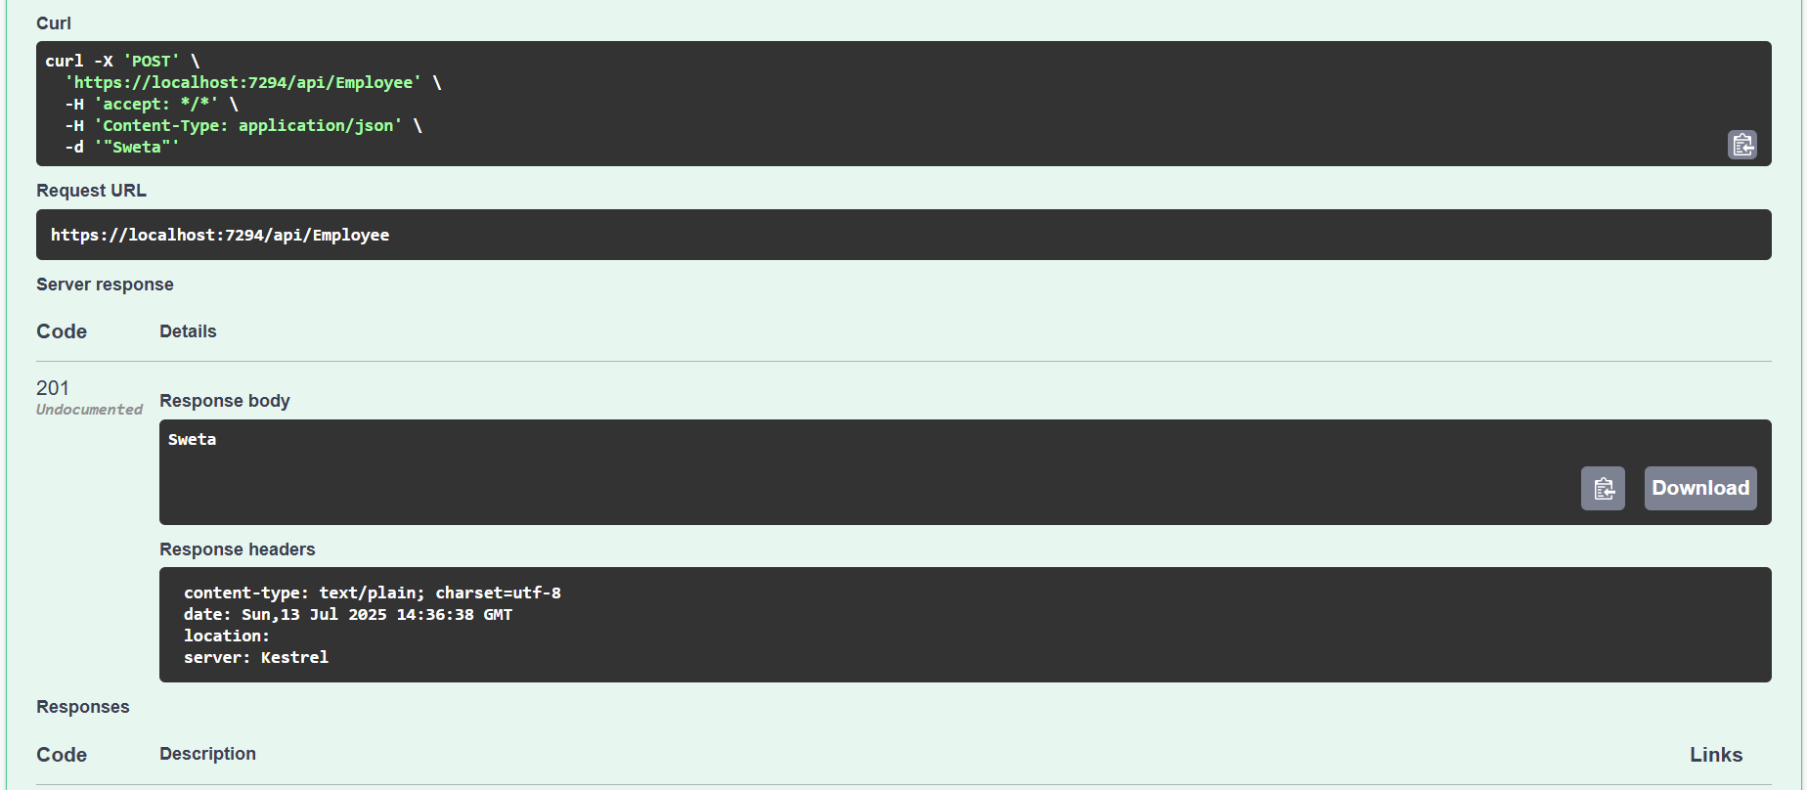

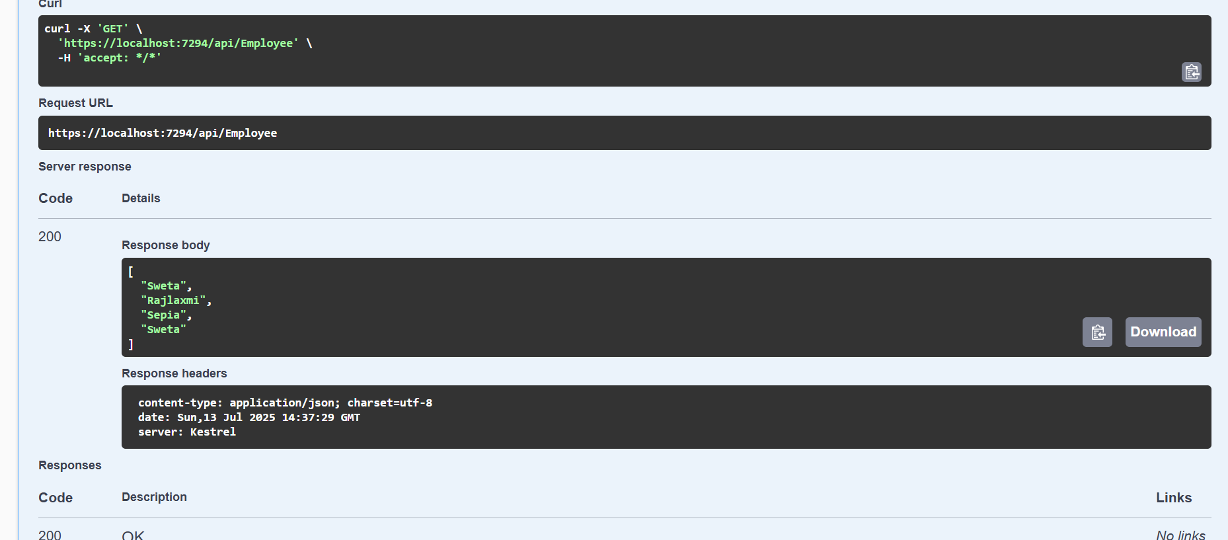

**Postman**

Use the POSTMAN tool, to point to the local Web API that was created with the Employee controller. Test the GET action method using POSTMAN. Verify the output if the List of employees are listed in the ‘Body’ part of the GET window on the POSTMAN tool. Verify the Status on the right side of the output pane on POSTMAN tool.

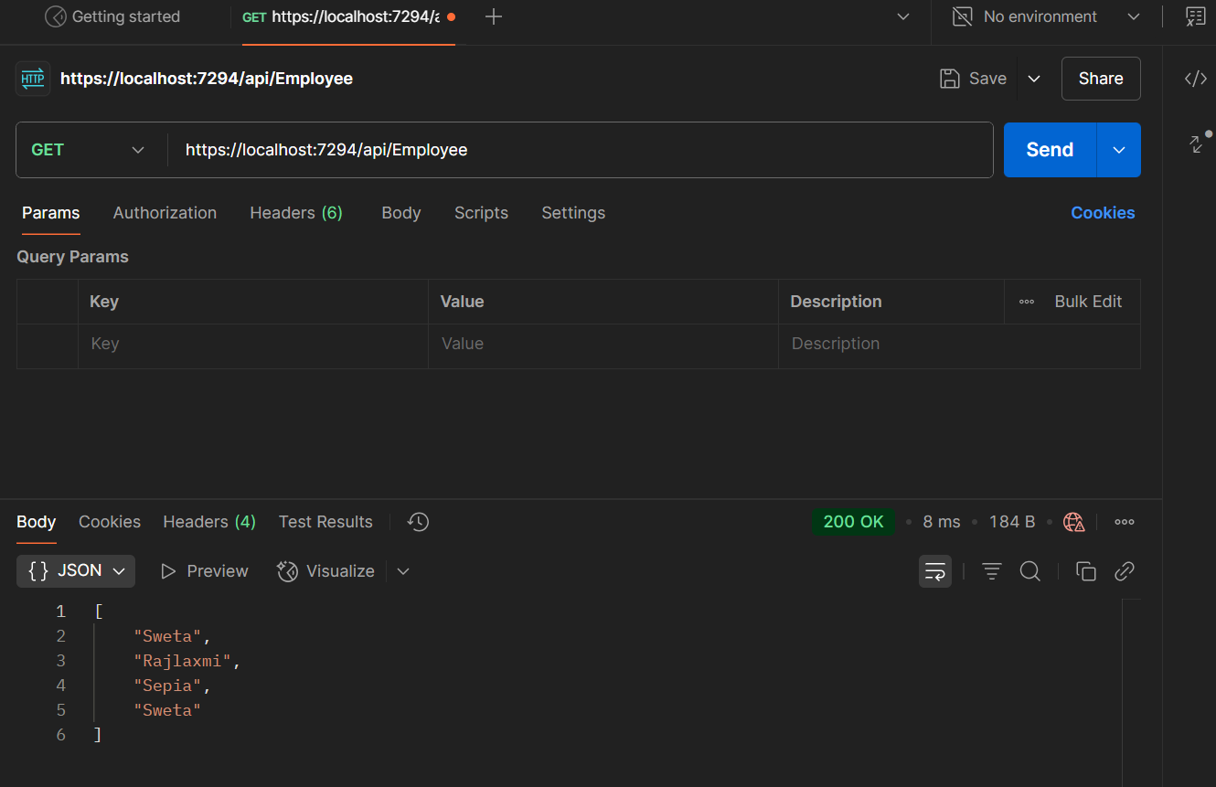

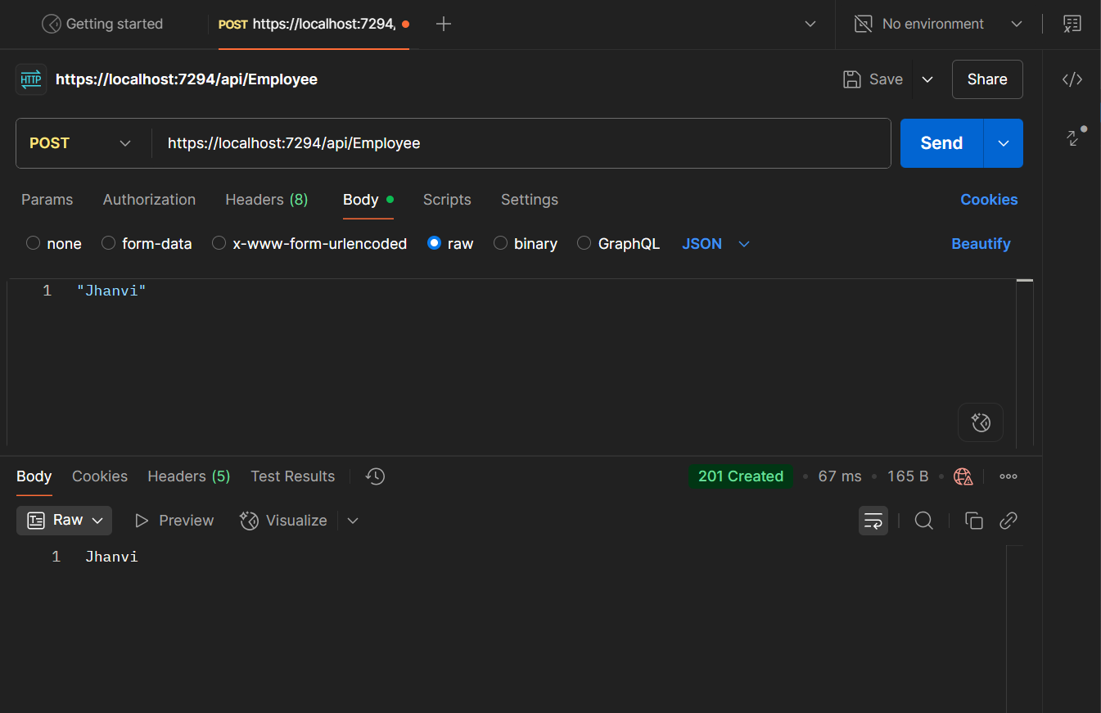

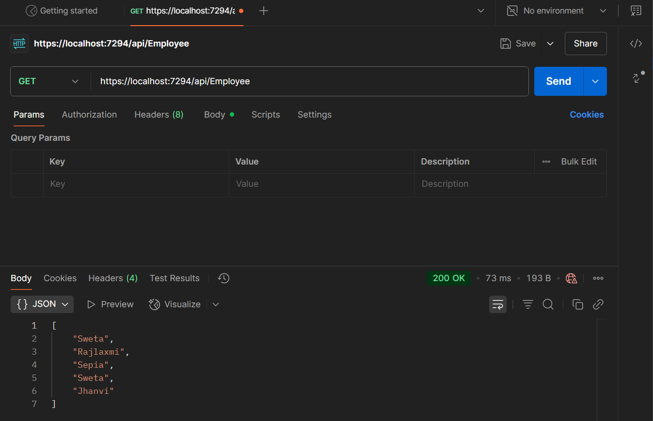

Modify the Controller name in the Route attribute of the Employee controller to ‘Emp’ and check its access through POSTMAN

